Die Yield Prediction

Problem Statement
Multi-Resolution Die Yield Prediction with Interpretable Spatial Context

Background
In semiconductor manufacturing, each wafer contains thousands of dies arranged in a grid. Each die undergoes electrical testing that produces multiple parametric measurements. Additionally, each die contains internal blocks that produce sub-die-level test readings — a high-dimensional signal that captures fine-grained process variation within the die. However, dies don't fail in isolation — failures are often influenced by neighbourhood effects (nearby defective dies), wafer-level process gradients (radial/linear variations from the chamber), and patterns hidden within block-level test readings.

Objective
Build two models and compare their performance:

Model A — Die-Level Only Predict per-die pass/fail probability using:
- Die-level features (n parametric test measurements per die)
- Spatial context (neighborhood pattern in the surrounding m×m window, derived from die positions)

Model B — Die + Block-Level Predict per-die pass/fail probability using everything in Model A, plus:
- Block-level readings (a dense array of k test readings per die, capturing sub-die process variation)

The goal is to demonstrate whether and how much the high-dimensional block-level signal improves prediction over die-level features alone.

Sample Wafer Map Visualization
Below is an example wafer showing pre-test state, post-test state, and newly failed dies:
- Green: Passing dies
- Red: Pre-test failures (old_label = 1)
- Orange: Newly failed dies after test (prediction target)

The challenge is to predict which green dies in the pre-test map will turn orange/red in the post-test map.

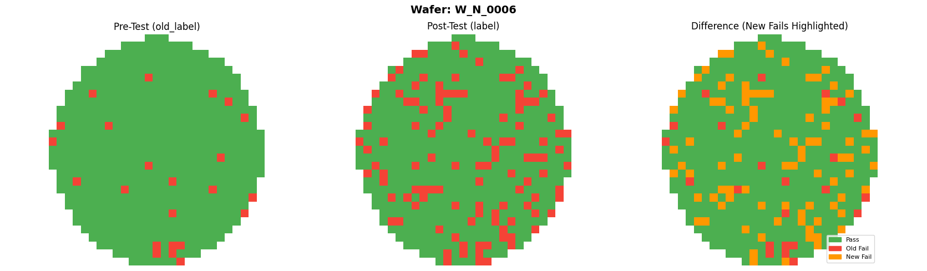
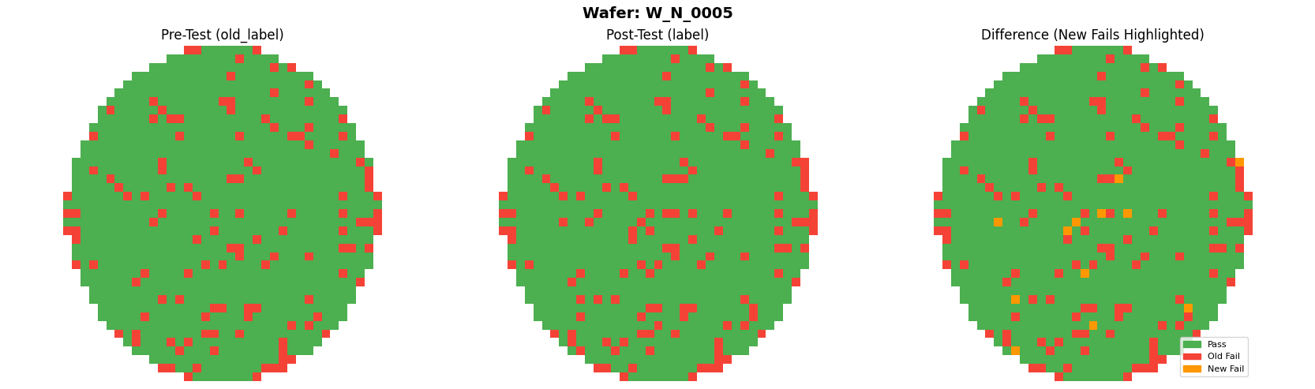

Key Challenges
- Extreme class imbalance — only ~2-5% of dies fail
- High overlap — most failing dies have feature distributions that heavily overlap with passing dies (marginal failures)
- High-dimensional block data — each die has ~2000 block readings; the model must handle dimensionality reduction, embedding, or direct modeling of this signal
- Interpretability required — for each predicted failure, the model must output which features (and which block-level patterns, for Model B) and which spatial context contributed most to the prediction (engineers need actionable root cause, not a black box)

Evaluation Criteria
Criterion | Weight
Prediction performance — Model A vs Model B comparison (F1, AUC-PR on minority class) | 30%
Handling of imbalance (no trivial "predict all pass") | 20%
Model interpretability (feature attribution, block pattern analysis, spatial heatmaps) | 30%
Creative use of multi-resolution data fusion and improvement analysis (Model A → B delta) | 20%

Data Approach
The WM-811K wafer dataset is used as the spatial foundation, with synthetic die-level parametric features and block-level readings to be generated on top of it.

Expected Deliverables
- Model A: A trained model that takes (m × n) die-feature matrix + spatial context → outputs (m × 1) failure probabilities
- Model B: A trained model that takes die-feature matrix + spatial context + block-level readings → outputs (m × 1) failure probabilities
- Comparison analysis: Side-by-side performance metrics (F1, AUC-PR, accuracy) showing improvement (or lack thereof) from adding block-level data
- Interpretability output: per-die feature importance + spatial contribution visualization (Model A), plus block reading pattern analysis (Model B)
- Analysis of how each model handles the imbalanced, overlapping distributions

Setup
- Download the provided zip file and extract it to a local directory
- Navigate to the extracted folder
- Create and activate a virtual environment (recommended):
  - Windows: python -m venv venv && venv\Scripts\activate
  - Linux/Mac: python3 -m venv venv && source venv/bin/activate
- Install dependencies: pip install -r requirements.txt
- Download the reference dataset: https://www.kaggle.com/datasets/qingyi/wm811k-wafer-map
- Place LSWMD.pkl in data/ directory
- Run generate_data.py to produce the training, test, and validation datasets

